EXERCICIS MODELATGE I QUERIES SQL

MODELATGE BBDD

1.

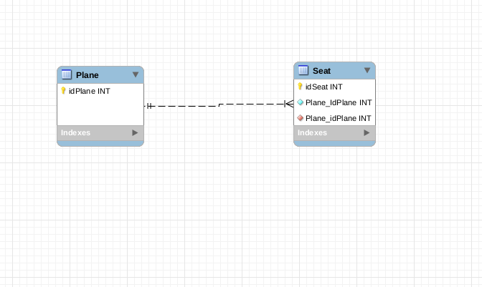
2.

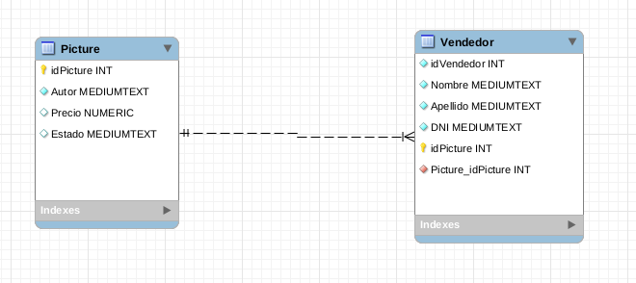

3.

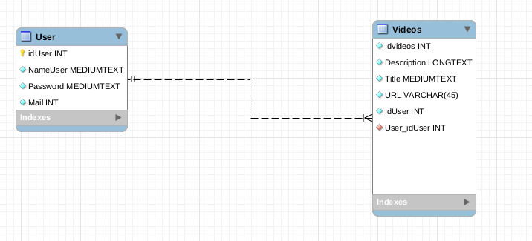
4.

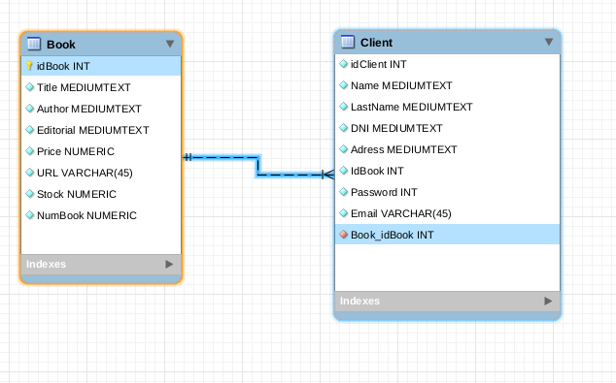

5.

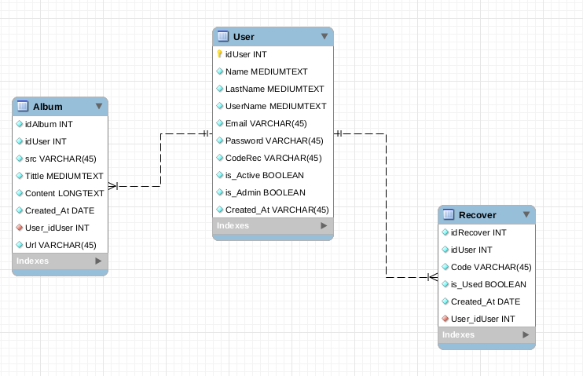
6.

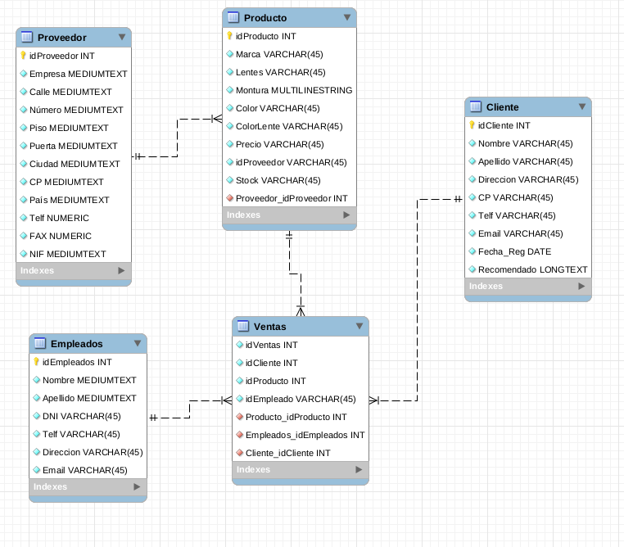

QUERIES SQL

1.

SELECT COUNT(flightID) As Total
FROM Flights;

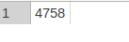

2.

SELECT Origin, AVG (ArrDelay) AS prom_arribades, AVG (DepDelay) AS prom_sortides
FROM Flights
GROUP BY Origin;
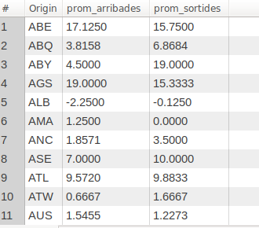

3.

SELECT Origin, colYear, colMonth, AVG (ArrDelay) AS prom_arribades
FROM Flights
GROUP BY Origin, colYear, colMonth
ORDER BY Origin , colYear, colMonth;

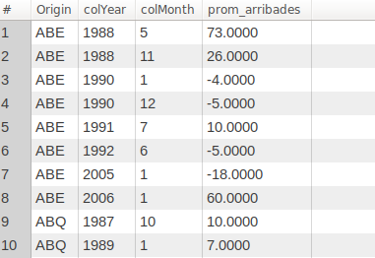

4.

SELECT USAirports.City, colYear,colMonth, AVG (ArrDelay) AS prom_arribades
FROM USAirports RIGHT JOIN Flights ON USAirports.IATA = Flights.Origin
GROUP BY USAirports.City, colYear,colMonth
ORDER BY USAirports.City;

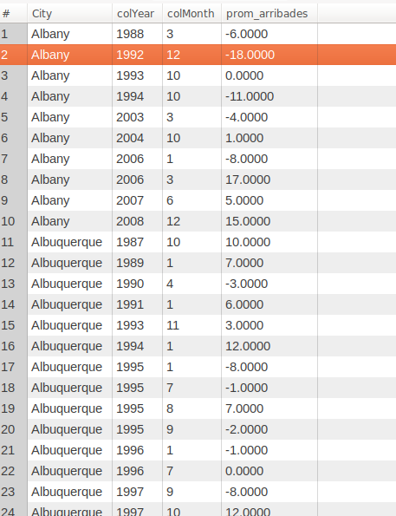

5.

SELECT UniqueCarrier, colYear, colMonth, AVG (ArrDELAY) AS avg_delay, SUM(Cancelled) AS total_cancelled
FROM Flights
GROUP BY colYear, colMonth
ORDER BY total_cancelled desc;

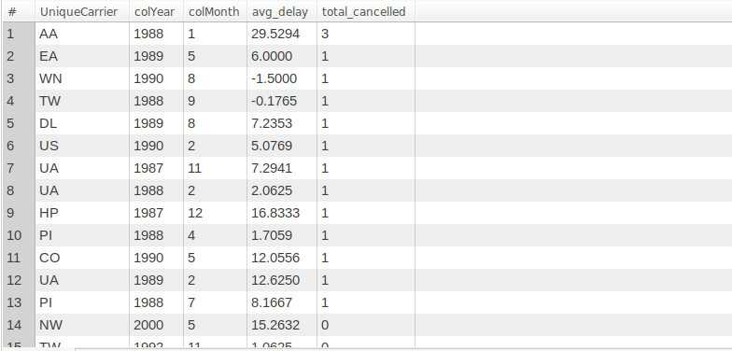
6.

SELECT TailNum, SUM(Distance) AS totalDistance
FROM Flights
WHERE TailNum > "1"
GROUP BY TailNum
ORDER BY totalDistance desc;

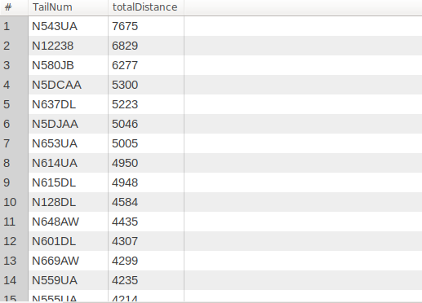

7.

SELECT UniqueCarrier, AVG (ArrDelay) AS avgDelay
FROM Flights
WHERE ArrDelay > "10"
GROUP BY UniqueCarrier
ORDER BY ArrDelay;

